# Lab 10: Shell and Tube Heat Exchanger

Alia binti Mohd Zaki

4/10/2020

**1. Figure and Tables**

**Table 1a.** Table presenting the hot-side and cold-side mass flow rate $ṁ$, temperature difference $∆T$, overall heat transfer coefficient $U,$ heat transfer rate $q$, and heat transfer rate percent difference $∆q$.

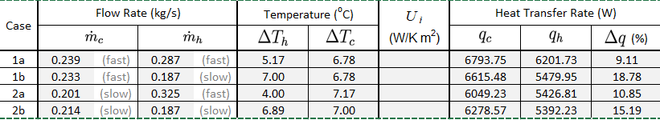

**Table 1b.** Table presenting the hot-side and cold-side mass flow rate $ṁ$, heat capacity ratio $C_{r},$ number of transfer units $NTU$, and measured, theoretical, and percent different difference of effectiveness $ε$

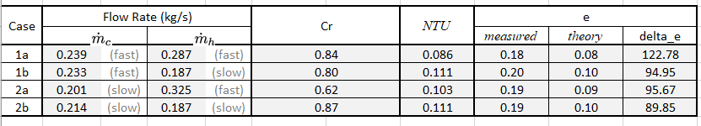

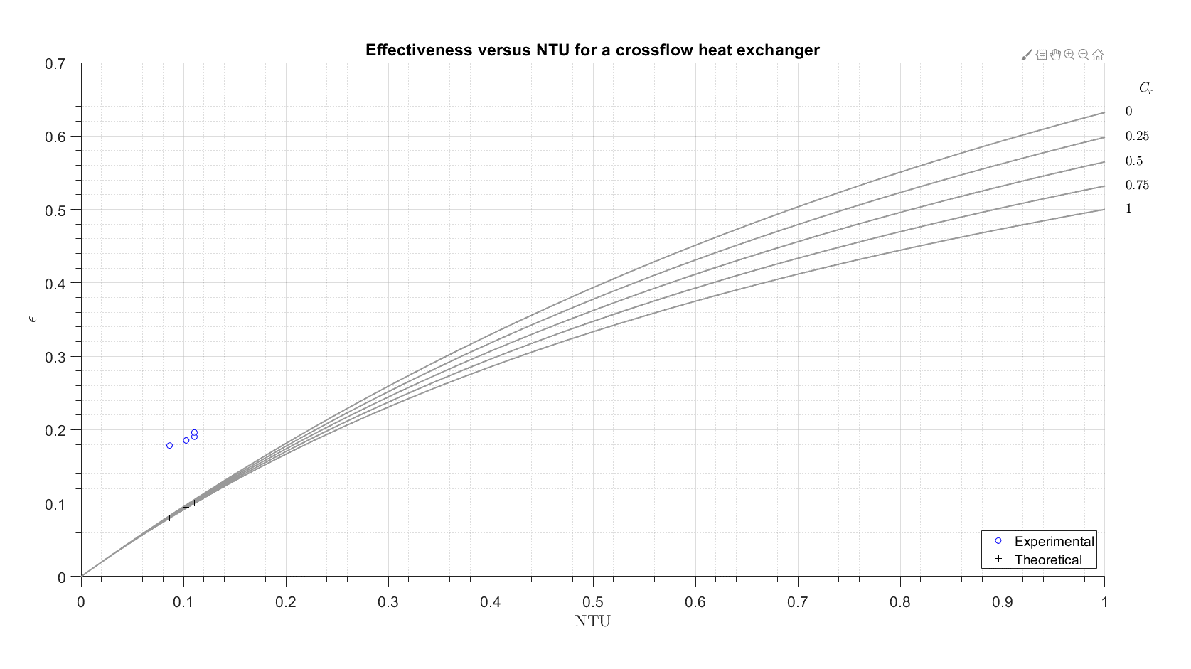 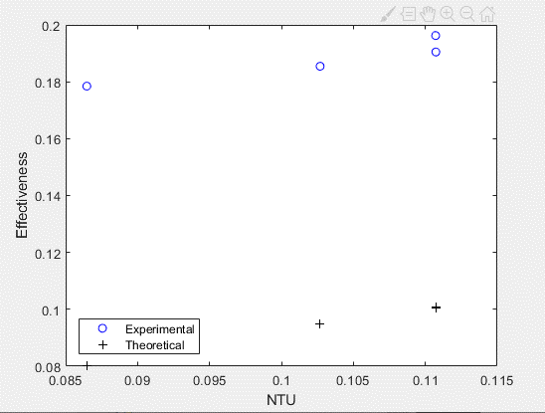

**Figure 1c.** Plot of the effectiveness $ε$ versus number of transfer units $NTU$

**2. Short Answer Questions**

1. *Theoretically, we expect qh = qc. However, your measurements will not likely support this. In your analysis, you calculated the percent relative difference, ∆q, between qc and qh. State the range of ∆q calculated from your measurements. In addition, state the range of percent relative uncertainty in the calculated heat transfer rates: (σqc /qc) · 100% and (σqh /qh) · 100%. State the extent to which the uncertainty in the measurements helps explain the observed difference between qc and qh? [3–4 sentences]*

The range of $∆q$ calculated is from 9.11-18.78%. The range of percent relative uncertainty in the calculated heat transfer rates is 3.84-6.67% and 5.26-6.25% for the hot and cold sides respectively. The uncertainties stated only explain the observed difference between qc and qh to the extent of thermocouple uncertainties and water level reading uncertainties. The uncertainties do not cover fouling or other human errors.

1. *State the percent difference in effectiveness values obtained from the measurements compared to theory (∆ε in %). Based on your engineering judgment, does the theory adequately describe the observations? For example, is it possible to use the theory to predict the effectiveness of the present heat exchanger for the following case: ˙mc =0.3 kg/s and ˙mh =0.4 kg/s? If yes, explain how. If no, explain why not. [3–5 sentences]*

The percent difference of effectiveness values obtained from the measurements are shown in the table below.

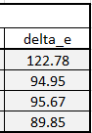

In this case, the theory does not adequately describe the observations due to a miscalculation in the code. Since the theory is invalid, it is not possible to use the theory to predict the effectiveness of the present heat exchanger.

1. *Estimate the rate of heat transfer from the shell casing to the surroundings due to natural convection (qconv) and radiation (qrad). State the qconv and qrad values in W averaged over all four test cases. Based on your engineering judgment, are these losses important and would you recommend insulating/covering the shell casing to mitigate these losses? Explain why or why not. [3–4 sentences] *Note, be sure to include your calculations for qconv and qrad in your computer code.*

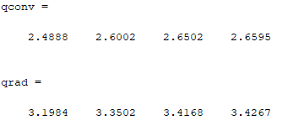

These values are in Watts. Since they are very small, these losses are not important. Insulation/covering of the shell would not be necessary in this case because of the small values.